DATA LINK LAYER OF ARP

## PROCEDURE:

* ARP protocol is the layer 2 protocol used to discover the mac address node with ipv4adres

*having the matching ip address ,router 1 sends an arp response includes its mac address

*host 1 transmitts the ip packet to layer 3 da using router 1’s mac address

*the host knows the destination ipv4 adress and users arp to resolve the destination mac

Address

*to display the arp table on syatem,enter the show arp command

* the command displays all arp entries in the system

Screen shot before stimulating the expriment

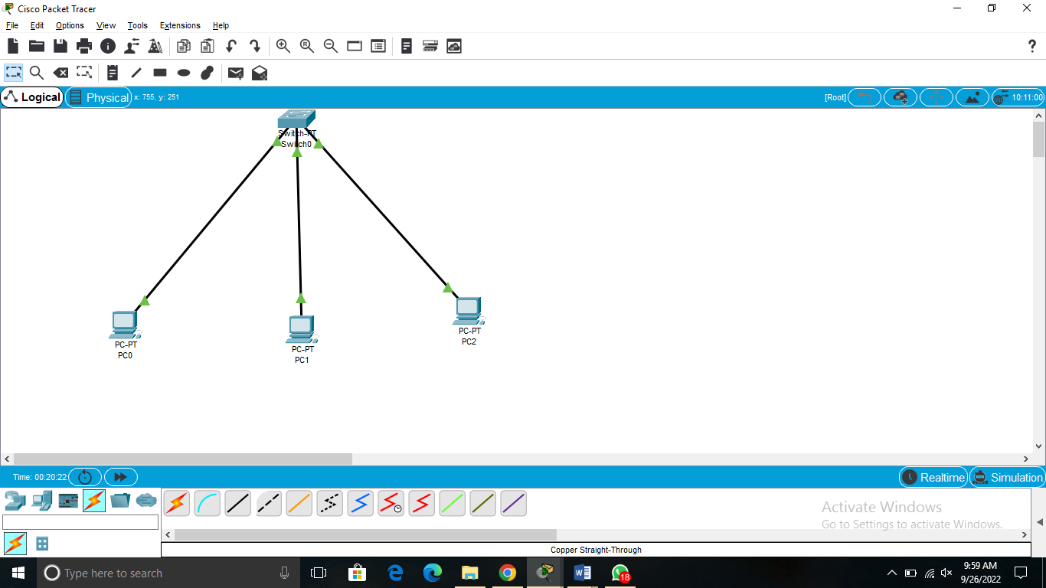

Screenshot during transferring the messages from one device to another devices

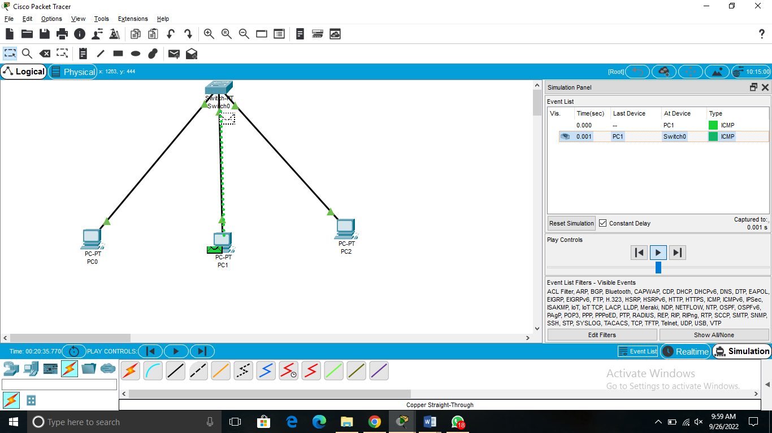

Screen shot taken after completing the stimulating process